|  |  |
| --- | --- |
| **Fundamentals for IT Professionals III**  Diploma in CSF/FI  Year 2 (2021/22), Semester 5 | Week 6 |
| **1** hour |
| **Activity Week 6 – Email Writing & Telephone Skills** | |

**OBJECTIVES**

* Email Writing & Telephone Skills

**ACTIVITIES**

1. The following are examples of erroneous email. Attempt to identify and correct the errors in each of the examples.

Example 1

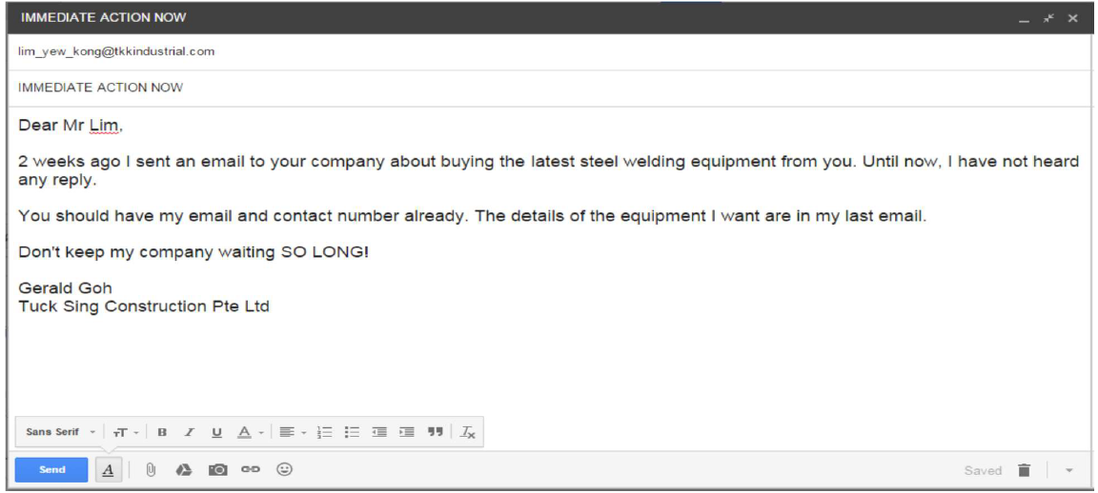

Example 1 - Corrected Email

|  |
| --- |
| To: [Lim_yew_kong@tkkindustrial.com](mailto:Lim_yew_kong@tkkindustrial.com)  Subject: Request for Response  Dear Mr Lim,  I am Gerald Goh from Tuck Sing Construction Pte Ltd. I had sent an email 2 week ago regarding the purchase of the latest steel welding equipment and hope that you can review that email.  The email contains the item order and my contact detail.  Hope to hear from you as soon as possible.  Kind regards,  Gerald Goh  Tuck Sing Construction Pte Ltd |

Example 2

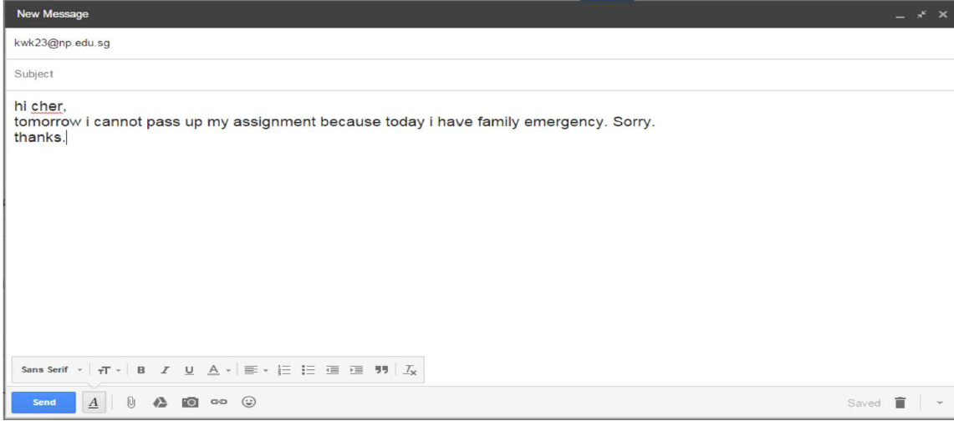

Example 2 - Corrected Email

|  |
| --- |
| To: [kwk23@np.edu.sg](mailto:kwk23@np.edu.sg)  Subject: Request for Assignment Submission Deadline Extension  Dear Lecturer,  I am Jia Shun, a student from class P02. I wrote this email to inform you that I will not be able to submit your assignment for FP3 tomorrow due to a family emergency. I would like to request for an extension to the deadline.  Apologies for the late notice.  Best Regards,  Tan Jia Shun  Student of Ngee Ann Polytechnic |

Example 3

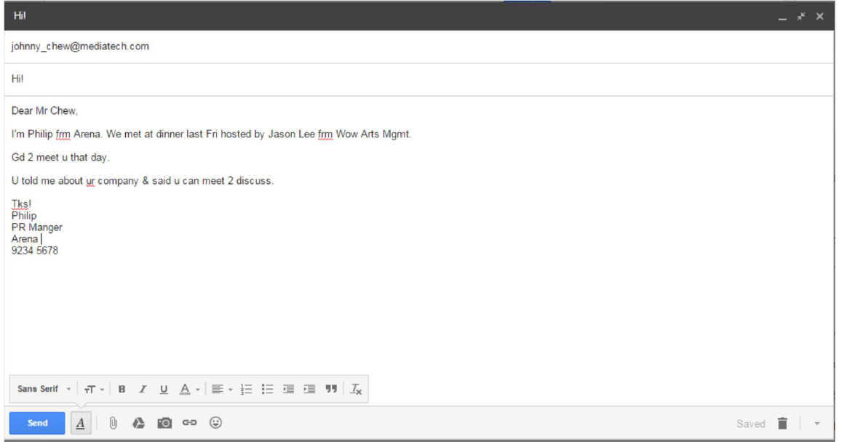

Example 3 - Corrected Email

|  |
| --- |
| To: [johnny_chew@mediatech.com](mailto:johnny_chew@mediatech.com)  Subject: Possible Business Collaboration  Dear Mr Chew,  I am Philip from Arena. It was a pleasure meeting you on last Friday dinner hosted by Jason Lee from Wow Arts Management.  After hearing from you about your company that day, I would like to meet up with you next week to discuss more about your company. Will like to check when will you be free next week?  You can also contact me on my cell phone at 9123 4567.  Kind regards,  Philip  PR Manager of Arena |

Example 4

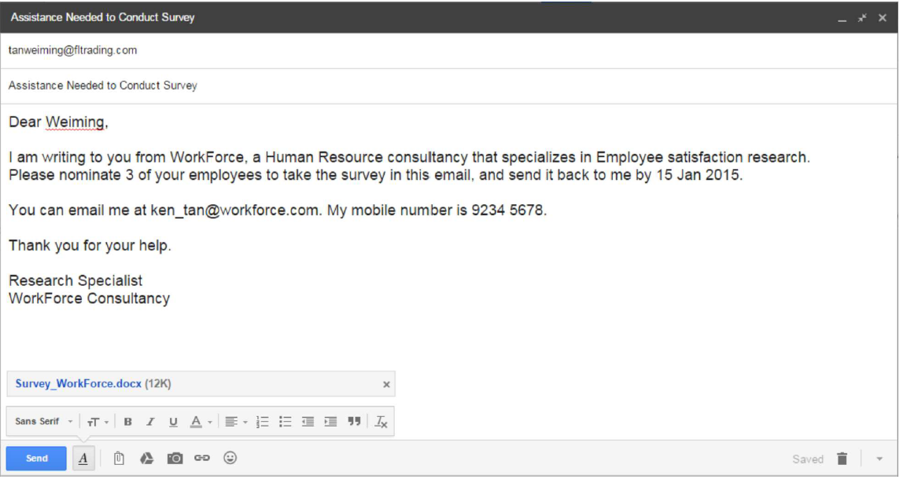

Example 4 - Corrected Email

|  |
| --- |
| To: [tanweiming@fltrading.com](mailto:tanweiming@fltrading.com)  Subject: Assistance Needed in Nominating Participants for Survey  Dear Wei Ming,  I am Ken Tan from WorkForce, a Human Resource consultancy that specializing in Employee Satisfaction research.  I am writing this email to request for your help in nominating three of your employee to participate in a survey that is attached to this email. It is appreciated that you could send me the completed surveys by 15th January 2015.  I could be reach at ken_tan@workforce.com or through phone calls at 9234 5678.  Thanks in advance.  Ken Tan  Research Specialist  WorkForce Consultancy |

1. Write emails for the following situation:

You have just attended a job interview today/yesterday. You would like to make a positive impact on the interview panel or the key person/HR person in the panel.

Write an email to this person to thank him / her.

|  |
| --- |
| To: [enquiry@experis.com.sg](mailto:enquiry@experis.com.sg)  Subject: Expression of gratitude for yesterday interview  Dear [Name of HR Person],  I am Tan Jia Shun from Ngee Ann Polytechnic. I attended the interview yesterday and feel extremely grateful to be able to meet you. From the interview, I get to learn more about the company culture and the job scope.  I look forward to hear regarding the results of the interview.  Best regards,  Tan Jia Shun |

1. Submission

* Submit your completed activity to MeL:

Groups🡪 *<student group>* 🡪Group Discussion Board 🡪 Week 8 Submission